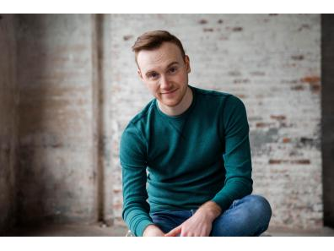
Jake Alexander
Playwright and Theatre Artist
860-367-6441
alexanderjake34@gmail.com
jakealexanderplaywright.com

Education
Boston College (BA) Applied Psychology/English with a minor in Theatre
Playwriting (all works can be read on NewPlayExchange or PWCenter.org)
____________________________________________________________________________________________________________________________________
PRODUCTIONS & READINGS
But Did I Leave the Oven On? Equity Library Theatre Winter Festival, Apr. 2021 (Finalist);
Christopher Newport University Theatre Dept., Dec. 2021
Yland Quarantine Reading Society, Mar. 2021;
Developmental Reading, Feb. 2022
Emergency Contact SOOP Theatre Co. One Act Festival, Nov. 2021(Finalist);
SPF at the Player’s Theatre, Feb. 2022 (Winner)
University of Central Missouri Theater Dept., May 2025
It Was, You Know, What It Was Jakespeare Virtual Theatre Festival, Feb. 2022
Knock It Off, I Love You NY Theatre Festival Summerfest, June 2022 (solo show: wrote, produced and performed)
Any Other Day Chestnut Street Playhouse New Play Festival,
September 2022
Broward College Theatre Dept. Second Stage,
December 2022
You’re Not Allowed to Ask Me That Emerging Artists Theatre Co. Spark Theatre Festival
March 2023
Chestnut Street Playhouse, one-night only benefit
June 2023
The Tank NYC
April 2024
Easy Does It Rockford New Words Festival 2024
February 2024
Like a Good Neighbor Maker’s Ensemble, (solo show: wrote, produced, performed)
August 2025
_______________________________________________________________________________________________________________________
RESIDENCIES
Foster’s Theatrical Artist Residency Cultivating Curiosity, Summer 2021 (Playwright)
_______________________________________________________________________________________________________________________
SELF PRODUCED
Forgive Me Videography by Jake Alexander
Emergency Contact, a short-film Videography by Danny Zawodny
__________________________________________________________________________________________________________________________________
PUBLICATIONS
Emergency Contact Qu Literary Magazine, Winter 2022 Publication
It Was, you know, What It Was Literature Today Digital Magazine, 2023 Publication
Drier and Drier Fish Drama Anthology Fresh Words, 2023 Publication
Red Flag Literature Today Zine, 2025 Publication
Drama Anthology Fresh Words Publication, May 2025

